

**Fundamental of Programming**

**Name: Muhammad Amad Naeem**

**CMS id: 467469**

**Section: ME-15, Sec-B**

**Task 1:**

#include<iostream>

usingnamespace std;

int main() {

int i, num1, num2, a, hcf, lcm;

cout<<"Enter 1st number : ";

cin>>num1;

cout<<"Enter 2nd number : ";

cin>>num2;

if (num1>num2){

a=num1;}

else {

a=num2;}

for ( i = 1; i<=a; i++) {

if (num1%i==0 && num2%i==0){

hcf = i;

}

lcm= (num1*num2)/hcf;}

cout<<"Lcm= “<<lcm;

}

**Output:**

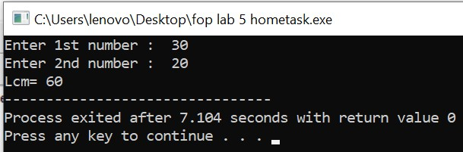

**Task 2:**

#include<iostream>

using namespace std;

int main() {

int a, n, d, sum;

cout<<"Enter the 1st term of sequence, a : ";

cin>>a;

cout<<"Enter the total number of terms in sequence: ";

cin>>n;

cout<<"Enter the common difference of sequence: ";

cin>>d;

sum = (n/2)*(2*a+((n-1)*d));

cout<<"Sum of series= "<<sum;

return 0;

}

**Output:**

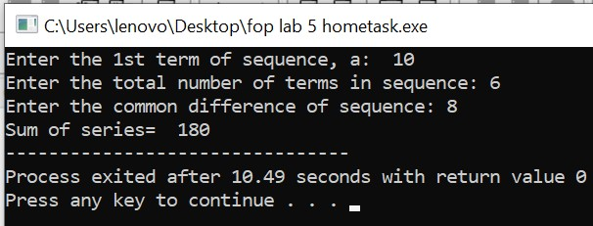

**Task 3:**

#include<iostream>

using namespace std;

int main() {

int n;

cout << "Enter Half Height: ";

cin >> n;

for (int i = 1; i <= n; i++) {

for (int k = n - i; k > 0; k--) {

cout << " ";

}

for (int j = 1; j <= 2 * i - 1; j++) {

cout << "*";

}

cout << endl;

}

for (int i = n - 1; i > 0; i--) {

for (int k = n - i; k > 0; k--) {

cout << " ";

}

for (int j = 2 * i - 1; j > 0; j--) {

cout << "*";

}

cout << endl;

}

return 0;

}

**Output:**

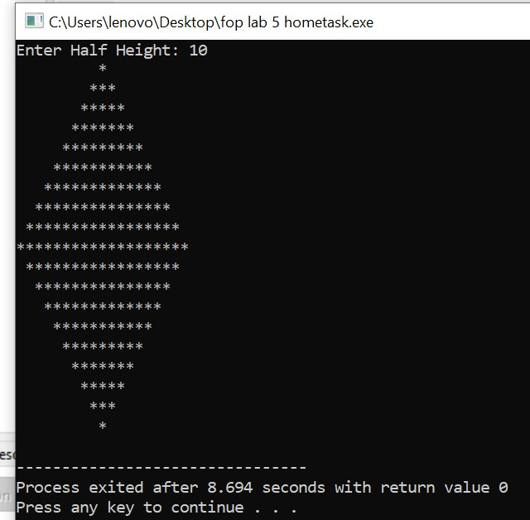

**Task 4:**

#include <iostream>

#include <string>

using namespace std;

int main()

{

int r, q, num;

cout<<"Enter a whole number(decimal): ";

cin>>num;

string bin;

q = num;

while(q != 0) {

r = q % 2;

q /= 2;

if (r == 1) {

bin = '1' + bin;

} else {

bin = '0' + bin;

}

}

cout<<bin;

}

**Output:**

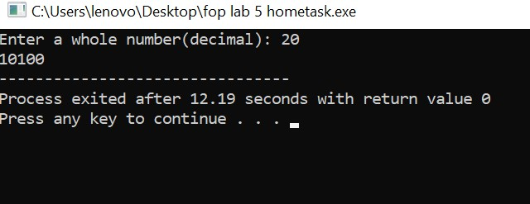

**Output:**